Unit 4 Test Credit Recovery!!!
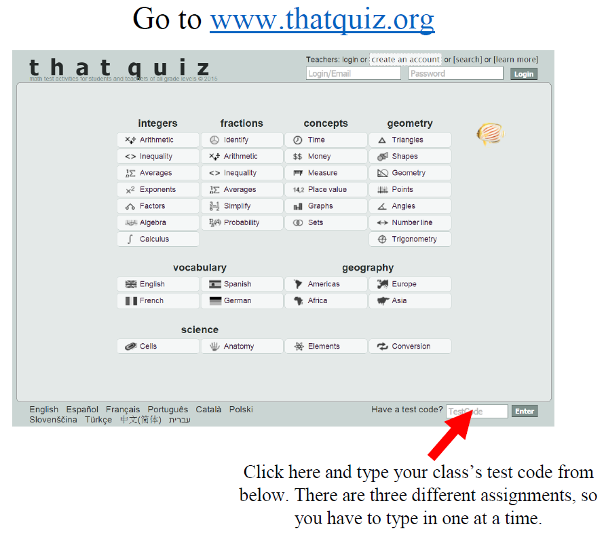
Assignment | 2nd Period | 6th Period | 7th Period
Unit 4 Test  Credit Recovery | AFN9RLXA | C56FLO8A | J3GF5F8N

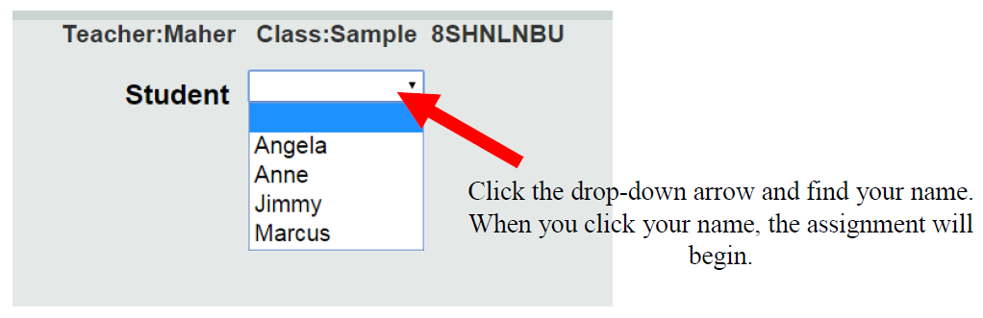
Mullis

