Unit 5 Test Credit Recovery!!!
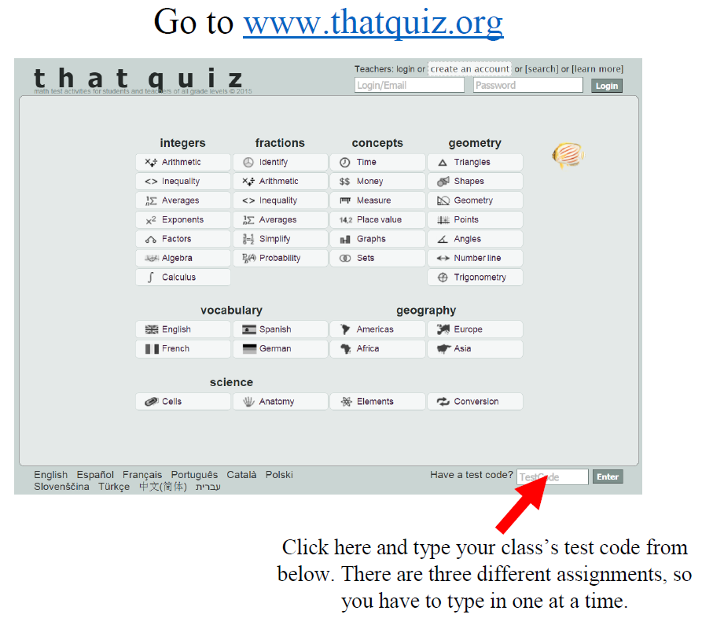
Assignment | 2nd Period | 6th Period | 7th Period
Unit 5 Test  Credit Recovery | W5VSOLBI | WFXDPVWP | VZNUNPWN

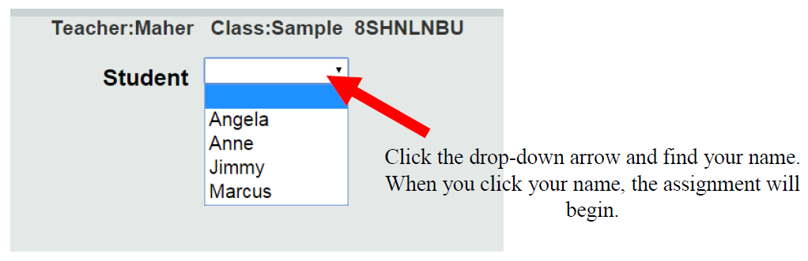
Mullis

