Credit Recovery - Unit 7 Test
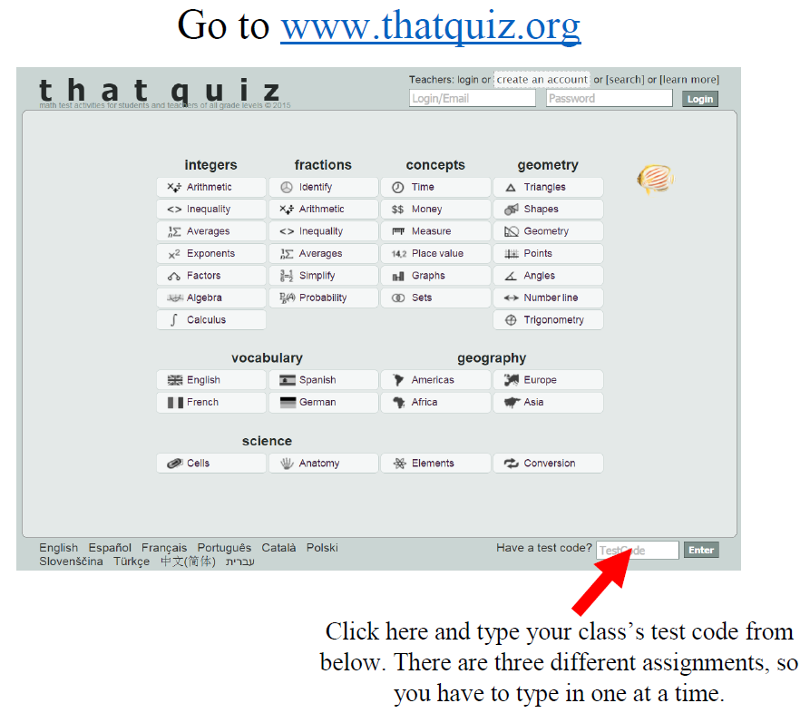
Assignment | 2nd Period | 6th Period | 7th Period
Solution Types | YTXTP2L4 | 4A76IRW4 | RLIKLWKK
Solving by Graphing | X571U5QG | K6NOG4KB | DDC7K4JV
Substitution / Elimination | CVLN7VCU | 391URW7J | WA13DXL4
Applications | 2X1DWT9X | P7R4RS9H | NNF2LFZA

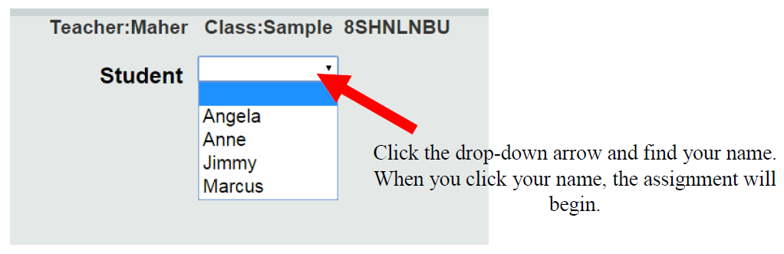
Mullis

