Spring Break EXTRA CREDIT!!!
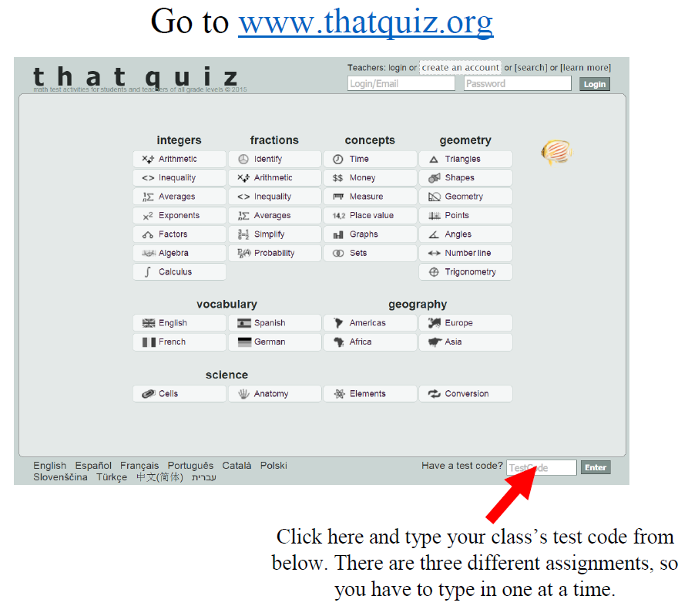
Assignments | 2nd Period | 6th Period | 7th Period
Math 8  Milestone Review | QNL9Q4DT | XZDMCN57 | ALVTFLM5

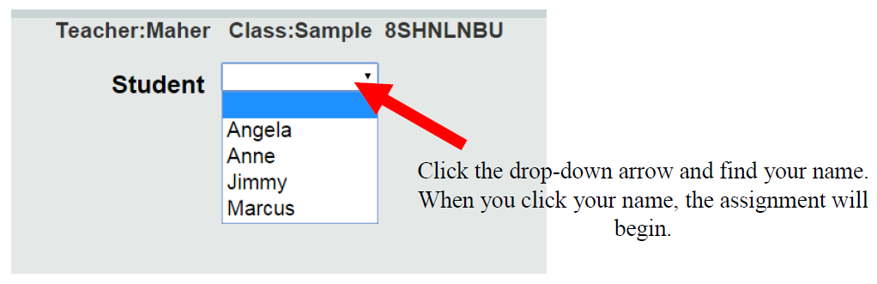
Mullis

