Spring Break EXTRA CREDIT!!!
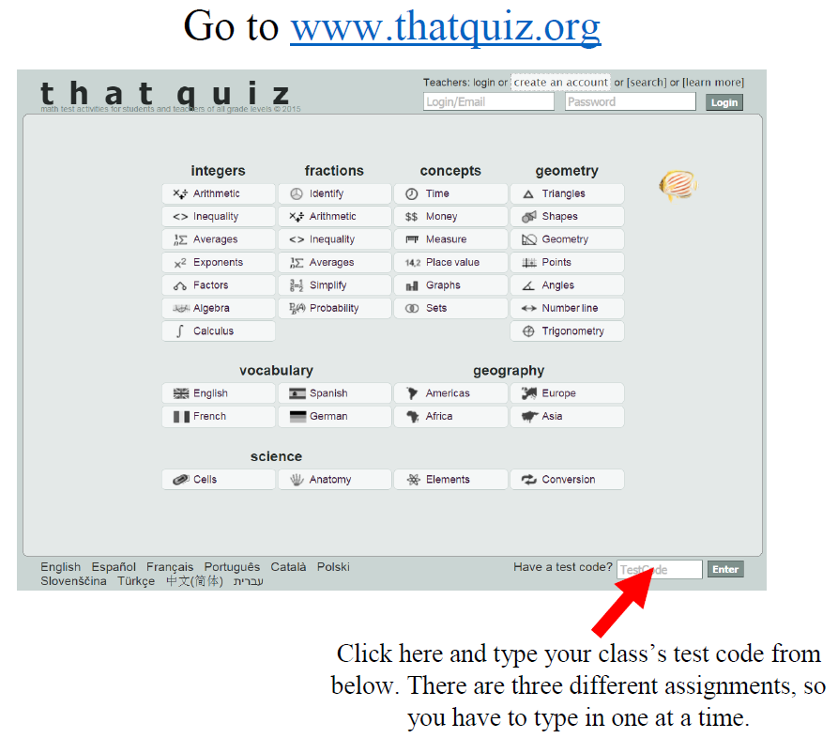
Assignments | 1st Period | 3rd Period
+/-/x/÷ Fractions | MXDJHXV5 | VG7AUAQ8
Integer Review Assessment | ZU1W22NE | I8VI8V7K
Graphing Linear Systems | ED9IWSLD | G8Q7AK5R

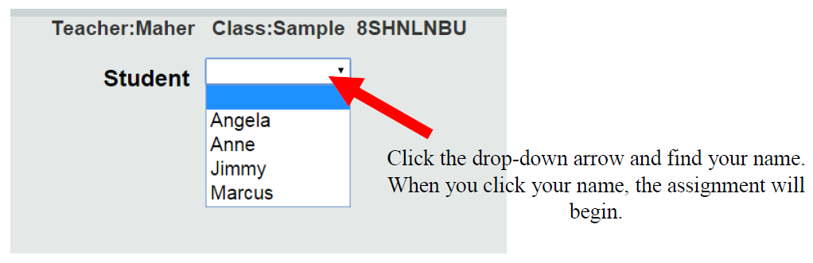
Mullis

