Semester Break EXTRA CREDIT!!!
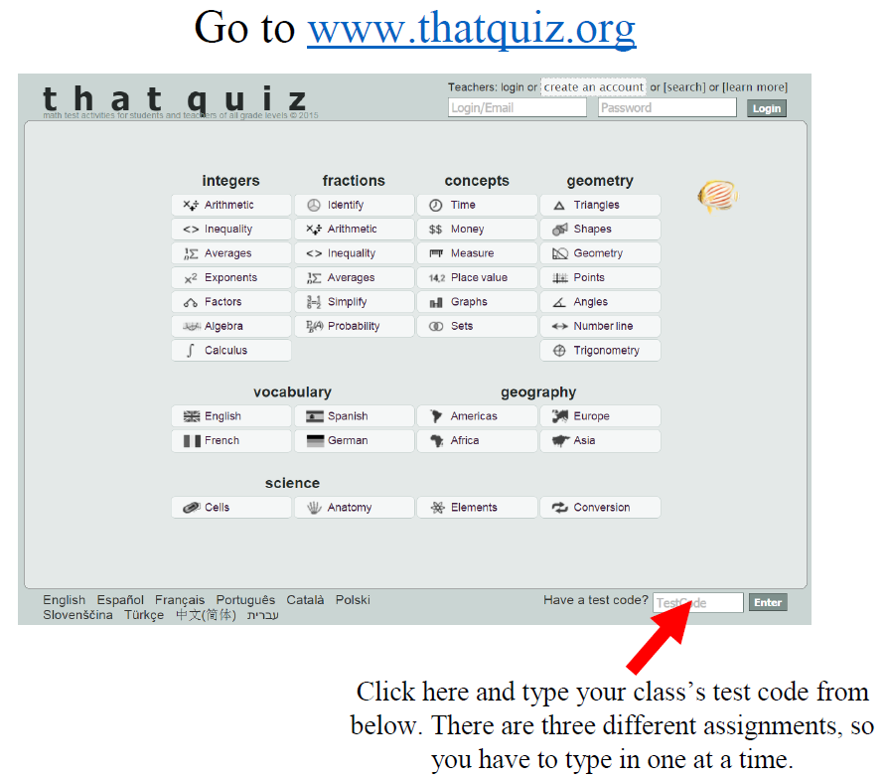
Assignments | 1st Period | 3rd Period
#1: Mixed Mult. Fact Drill | TOPUNHBQ | 1OAB8P5O
#2: Mult. Fact Timed Test | FNRZNDM9 | UGE7MGBJ
#3: Integers Review | OQYSY3JZ | G7FH8IIU
#4: Integer Operations | YYKU9MCP | 9KEA6MPX
#5: Fractions Practice | AOC8QDJP | 5GA36HFB

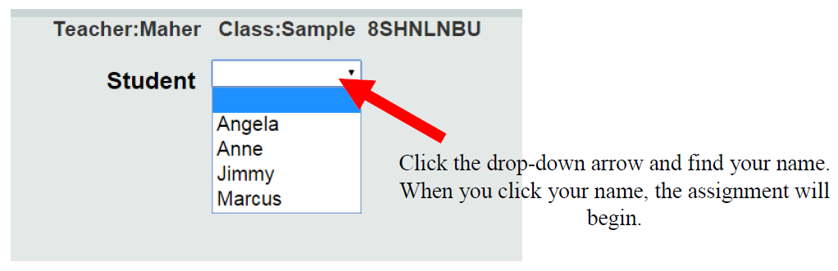
Mullis

