Winter Break Extra Credit!!!
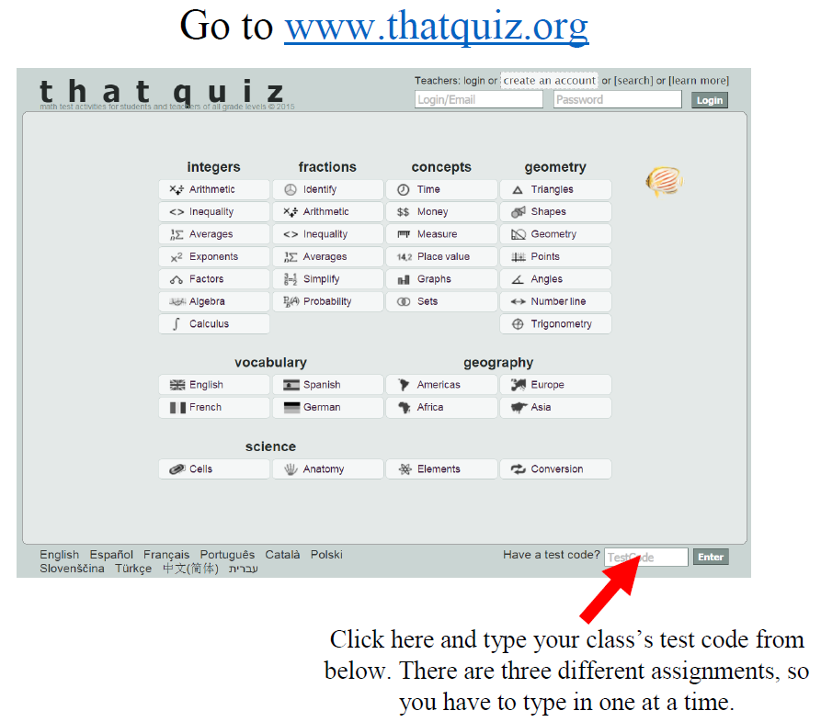
Assignment | 2nd Period | 6th Period | 7th Period
Extra Credit | XANQX7JE | O85E47I8 | ZW9ULZRR

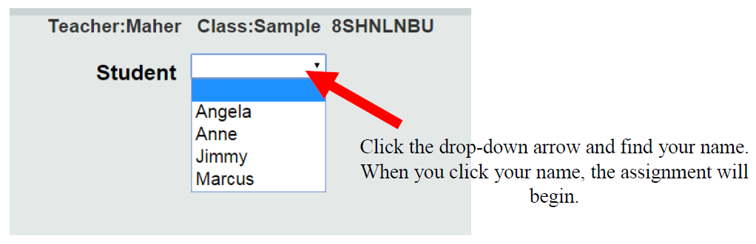
Mullis

