Winter Break EXTRA CREDIT!!!
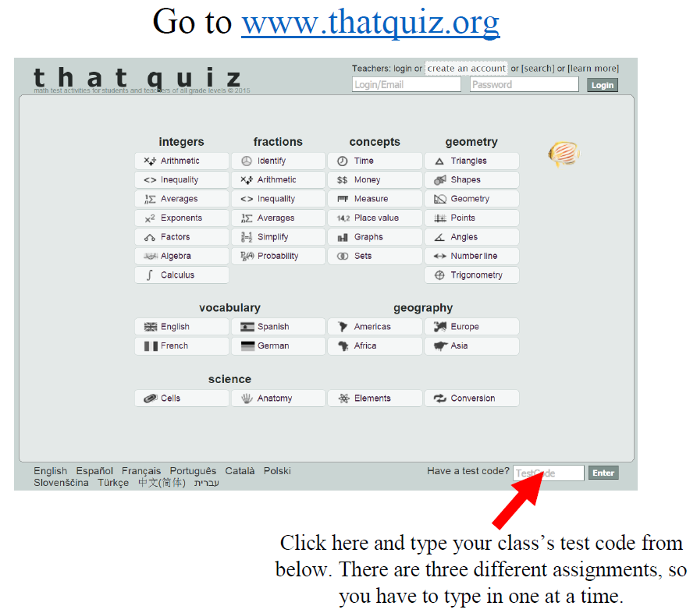
Assignments | 1st Period | 3rd Period
#1: Fractions | JTRPKFRB | KMB8TFYW
#2: Integers | 35ZKQJYU | HNBTCAWD

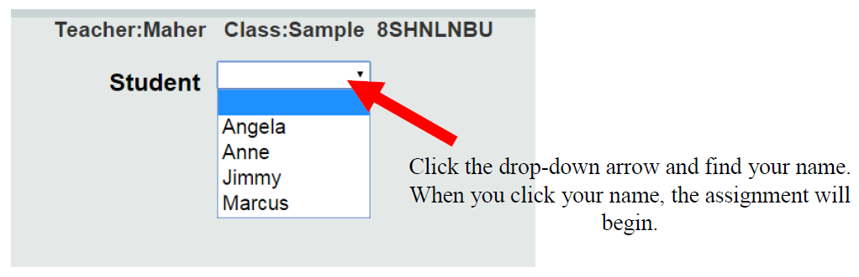
Mullis

