CCGPS Math 8 Name___________________________
Unit 4: Functions Date: 1/7/15 Class: 1 2 3 6 7
Function Practice
Directions: Read each question carefully. Show your work and choose the best answer.
1. Which of the following represents a function?  A) 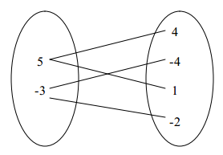 B)  C) 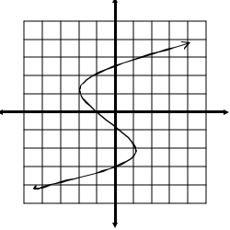 D) 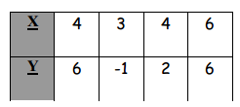 | 2. Does the following mapping diagram represent a function?  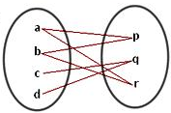  A) Yes B) No
3. Complete the function table using the given nrule.  x y=2x-3 y  -1  0  1  2 | 4. Which rule represents this function?  x y  3 -13  5 -21  6 -25  8 -33  A) y=-4x-1 B) y=x-16  C) y=-4x D) y=4x+1
5. Does the following table represent a function?  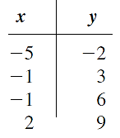  A) Yes B) No | 6. Does this graph represent a function?  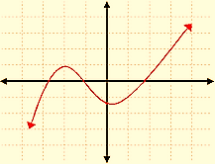  A) Yes B) No
7. Which of the following is NOT a representation of a function?  A) equation B) graph  C) ordered pairs D) exponents | 8. A function is defined by the rule y=6x-2. What would the output be when the input is 7?  A) 42 B) 40  C) 65 D) 69

