Name: ____________________________________ Date: ___________________
Directions: Complete each exercise correctly.
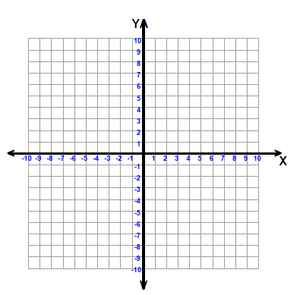
- Express the equation y = 2x in slope intercept form. __________________________________
What is the y – intercept of the line? __________
What is the slope of the line? ___________
Correctly graph the equation.

- Express the equation 6x + 2y = -8 in slope intercept form. __________________________________
What is the y – intercept of the line? __________
What is the slope of the line? ___________
Correctly graph the equation.

- Express the equation 3x + y = 5 in slope intercept form. ________________________________
What is the y – intercept of the line? __________
What is the slope of the line? ___________
Correctly graph the equation.

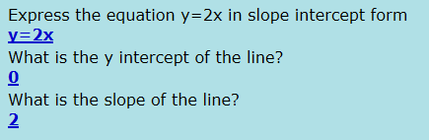
KEY

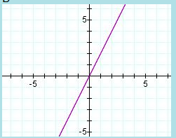
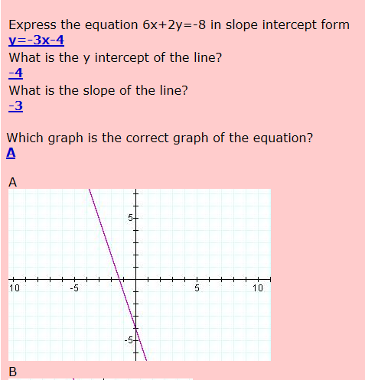

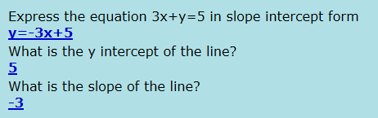

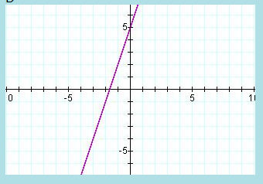

NAME: _______________________________________________ DATE:______________________
- Express the equation y = 3x - 4 in slope intercept form. __________________________________
What is the y-intercept of the line? ________
What is the slope of the line? _________
Graph the equation correctly.

- Express the equation 3x - y = 5 in slope intercept form. __________________________________
What is the y-intercept of the line? ________
What is the slope of the line? _________
Graph the equation correctly.

- Express the equation 4x - 3 y = 12 in slope intercept form. __________________________________
What is the y-intercept of the line? ________
What is the slope of the line? _________
Graph the equation correctly.

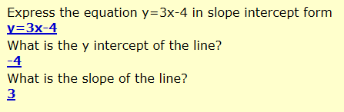
KEY
