Unit 6 Practice Test

- Where is the initial value of a graphed function?

  - The point where the line crosses the y-axis.
  - The point where the line crosses the x-axis.
  - The origin is always the initial value.
  - Count the rise and run.

- The fair charges an admission fee of $10 and $0.75 per ride. Which equation represents the situation?

  - $y=10x+75$
  - $y=0.75x+10$
  - $y=10x+0.75$
  - $y=10.75x$

- Victoria works at Turner Field selling posters of the Braves. She gets paid $35 per game plus $0.60 for each poster she sells. Which table shows the pay she can expect for any game as a function of the number of posters she sells.

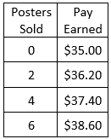
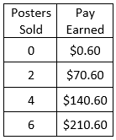
  - b. c. d.
Posters Sold | Pay Earned
0 | $0
2 | $155
4 | $275
6 | $396
Posters Sold | Pay Earned
0 | $0
2 | $1.20
4 | $2.40
6 | $3.60

- Hayden ate at Taco Mac for lunch. He ate 175 calories of French fries and x wings that were 60 calories each. Which equation describes the situation? How many calories did Hayden consume if he ate 12 wings?

  - $y=60x+175$; 895 calories
  - $y=175x+60$; 2,160 calories
  - $y=60+175+12$; 247 calories
  - $y=\frac{60}{12}x+175$; 180 calories

- Which equation has the greatest rate of change?

  - $y= -3x+2$
  - $y= \frac{1}{3}x-5$
  - $y=x+1$
  - $y= -\frac{3}{4}x-2$

- What is the rate of change for question #5?

  - -3
  - -5
  - $-\frac{3}{4}$
  - 1

- Which table has the lowest rate of change?

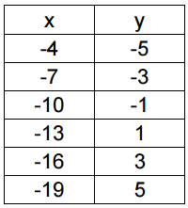
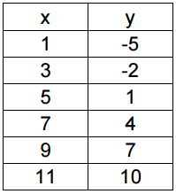
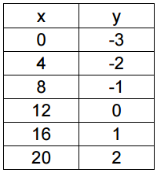
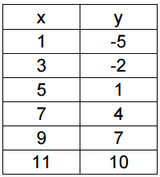
  - b. c. d.

- Is the rate of change in #7 increasing or decreasing?

  - Increasing
  - Decreasing

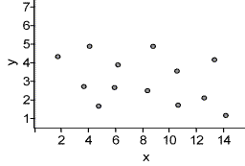
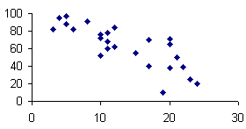
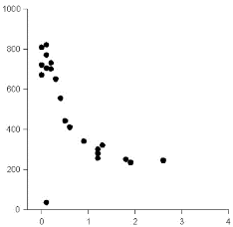
Use the scatter plots below to answer questions 9-13.
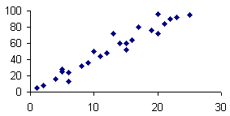
- b. c. d.

- Which scatter plot has a positive, linear association?
- Which scatter plot has a negative, linear association?
- Which scatter plot has a nonlinear association?
- Which scatter plot has an outlier?
- Which scatter plot has no association?
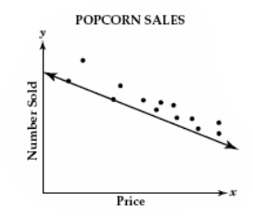
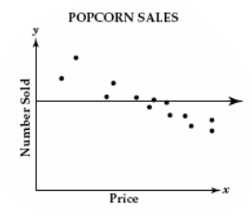
- Which shows the line of best fit for the scatter plot representing popcorn sales?
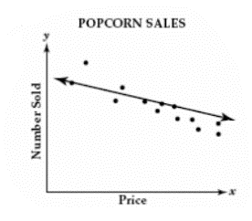
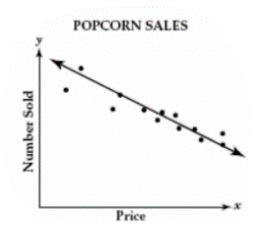
  - b. c. d.

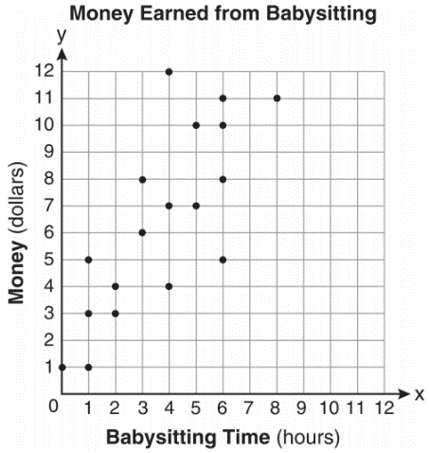
- Which equation best represents the line of best fit of the graph below?
- $y=x$
- $y=\frac{2}{3}x+1$
- $y= \frac{3}{2}x+4$
- $y=\frac{3}{2}x+1$

- Mrs. Maher got 40 bottles of soda for the 8th grade carnival. After serving drinks to 184 students, she had 17 bottles left. What is the rate of change of bottles to students?

  - $\frac{-1}{8}$ b. $\frac{17}{184}$ c. $\frac{17}{40}$ d. $\frac{-1}{4}$

- Eighth grade students were asked whether they participate in an after-school activity, and results are shown in the two-way table below. How many males participate in an after-school activity?

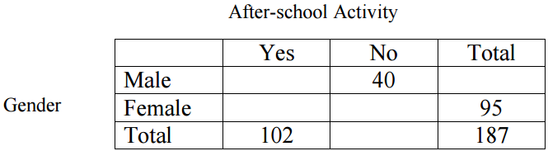
  - 187
  - 102
  - 92
  - 52

- A survey of students in a class explored the relationship between gender and if they watched this year’s Super Bowl. If a girl is chosen from the set of girls at random, what is the probability that she watched the Super Bowl?

  - 40%
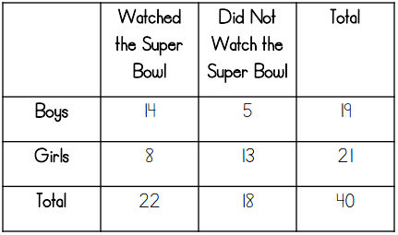
  - 20%
  - 38%
  - 8%

Answer Key
- A
- B
- D
- A
- A
- A
- A
- A
- B
- C
- D
- D
- A
- C
- D
- A
- D
- C

