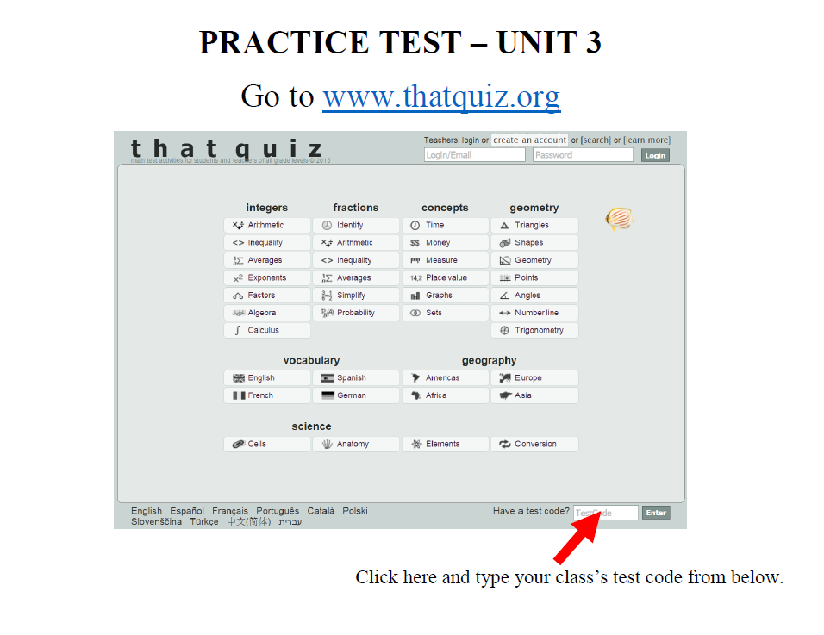
2nd Period | 6th Period | 7th Period
B7Q7SNY3 | 7134VZQJ | I2MPEWE1

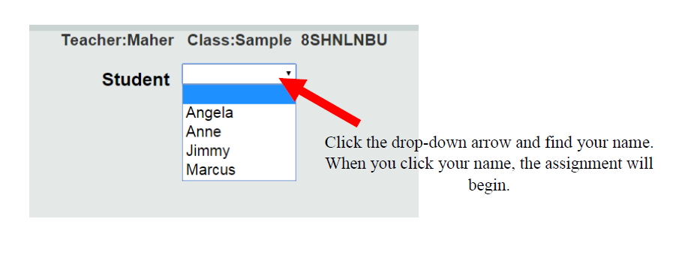
Mullis

