Rising 8th grade Summer Packet Name_______________________
DUE: Mon., Aug. 8, 2016
Dear Parents and Students,

This math packet contains 50 problems related to the 8th grade mathematics curriculum. The purpose of this packet is three-fold:

- Students will have the opportunity to review the 7th / preview 8th grade curriculum as a means to be better prepared for 8th grade math.

- Students will demonstrate their preparedness for this course and mastery of skills of the content necessary to experience success in this course.

- Students will gain a better understanding of the content/expectations of 8th grade math.

Additionally, resources are posted on Ms. Mullis’ blog as well as the Khan Academy or Google searches can help aid students in the areas or topics that require additional support. MullisMath.weebly.com

This packet will be due on Monday, August 8, 2016. It will be graded for accuracy. Students turning the work in by the first day of school, will have the opportunity to earn additional points.

We look forward to working with you and your child next school year.

Dora Brown, Lindsay Maher, Sara Mullis
8th Grade Math
Palmer Middle School

SOLVING EQUATIONS (Show your work – use another piece of paper, if you need more room)
Step 1: Use the inverse operation to isolate the variable.
Step 2: If a variable is multiplied by a fraction, multiply both sides by the reciprocal to cancel terms.
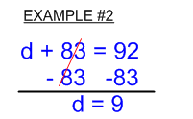
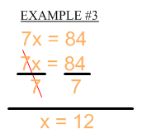
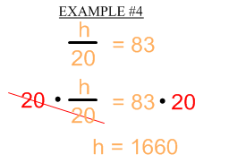
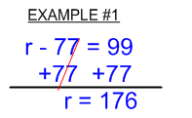
Step 3: Follow the order of operations backwards to isolate the variable.

1) x – 5 = 12 2) 4x = 12 3) $\frac{x}{5}$ = 10

4) x + 12 = 56 5) 0.2x = 12 6) $\frac{4}{7}x=12$

SOLVING EQUATIONS (Show your work – use another piece of paper, if you need more room)
Step 1: Distribute (if needed).
Step 2: Combine like terms (if needed).
Step 3: Follow the order of operations backwards to isolate the variable.
Example #1: Example #2: Example #3:
4x + 5x + 3 = 12 5(x – 3) = 20 5x + 2 = 7x – 6
9x + 3 = 12 5x – 15 = 20 –7x –7x
–3 –3 + 15 +15 –2x + 2 = –6
9x = 9 5x = 35 –2 –2
9 9 5 5 –2x = –8
x = 1 x = 7 –2 –2
x = 4
7) $5\left(x-4\right)=20$ 8) $7x-5x+2=8$ 9) $-4m+7=6m-3$

10) $2\left(x-4\right)=3x-8$ 11) $5x-2x+8=2+6x+6$ 12) $\frac{1}{2}x-3=\frac{2}{3}x-1$

MULTIPLYING FRACTIONS & MIXED NUMBERS (Show your work – use another piece of paper, if you need more room)
Step 1: Write mixed numbers and whole numbers as improper fractions (if applicable)
Step 2: Cross cancel – if applicable (this is optional)
Step 3: Multiply the numerators
Step 4: Multiply the denominators
Step 5: Simplify (if applicable)
13) $\frac{3}{4} ×\frac{4}{9}=$ 14) $\frac{3}{4} ×\frac{2}{5}=$ 15) $24 ×\frac{5}{6}=$

16) $2\frac{1}{4} ×\frac{1}{2}=$ 17) $3\frac{2}{3} ×2\frac{3}{4}=$ 18) $2\frac{3}{8} ×4\frac{7}{8}=$

DIVIDING FRACTIONS & MIXED NUMBERS (Show your work – use another piece of paper, if you need more room)
Step 1: Write mixed numbers and whole numbers as improper fractions (if applicable)
Step 2: Change the division to multiplication, and flip the second fraction (multiply by the reciprocal)
Step 3: Cross cancel – if applicable (this is optional
Step 4: Multiply the numerators, then multiply the denominators
Step 5: Simplify (if applicable)
19) $\frac{6}{7} ÷\frac{3}{7}=$ 20) $\frac{3}{4} ÷\frac{1}{2}=$ 21) $10 ÷\frac{5}{6}=$

22) $8 ÷2\frac{1}{4}=$ 23) $7\frac{2}{3} ÷1\frac{1}{6}=$ 24) $9\frac{2}{3} ÷2\frac{1}{6}=$

INTEGERS: Show your work – use another piece of paper, if you need more room)
To Add Integers: First, rewrite the problem so that there are no double signs. If both numbers have the same sign, keep the sign and add the numbers. If both numbers have opposite signs, subtract the numbers and keep the sign of the larger absolute value.
Examples: –4 + 3 = –1 5 + 2 = 7 –6 + –4 = –10 7 + –2 = 5
To Subtract Integers: First rewrite the problem so that there are no double signs. If the signs are the same in front of both numbers, then keep the sign and add the numbers. If the signs are different, subtract the smaller number from the larger number and keep the sign of the larger absolute value number.
Examples: 5 – 7 = –2 –8 – 2 = –10 5 – –2 = 5 + 2 = 7
To Multiply or Divide: Multiply or divide the numbers, then use the following criteria to choose the appropriate sign: multiplying or dividing two same signs results in a positive number. If you multiply or divide with two different signs (a positive and a negative), the result is a negative number.
Examples: –7$÷$ –1 = 7 6(–3) = –18 –5$∙$–3 = 15
25) 5 – 7 26) 5 $∙$ 7 27) 8 $÷$ –4 28) –1 + –6

29) –5 $∙$–8 30) 6 – 2 31) –12 $÷$ –3 32) –10 $∙$ 6

33) 0.2 $÷$ –10 34) –3.2 – 1.6 35) –12.7 $∙$ –1.65 36) 5.4 + 9.7

37) $\frac{4}{3}+ -\frac{3}{2}$ 38) $\frac{4}{7}∙-\frac{21}{28}$ 39) $-\frac{2}{5}÷-4\frac{1}{5}$ 40) $\frac{3}{12}-4\frac{1}{12}$

Directions: Graph each coordinate on the coordinate plane.
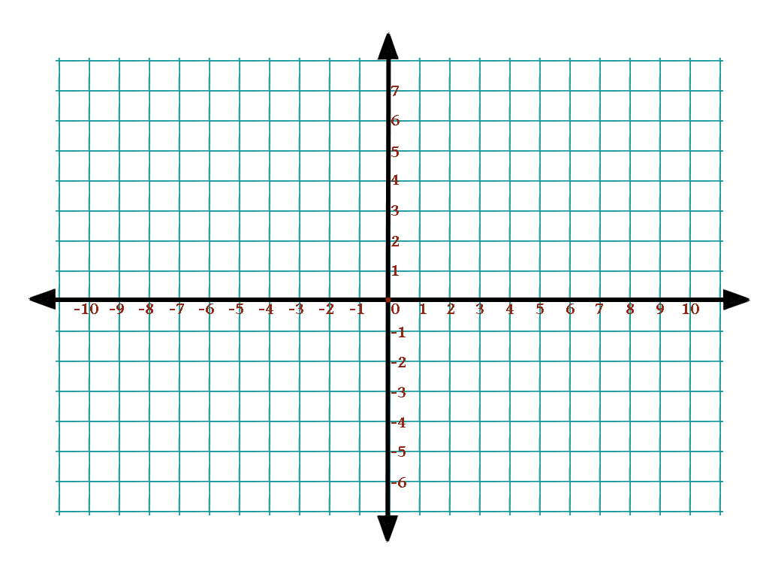
Example: Z(-6, 7)
Z(-6, 7)
41) A($-4,5)$
42) B($-2, -6)$
43) C(3, 7)
44) D($-10, 1)$
45) E($-3.5, -1.5)$
46) F(7, 4)
47) G(8, $-1)$
48) H($-\frac{3}{2}$, 5)
49) I(0, 8)
50) ($-4, 0)$

