Create Your Own Stained Glass:

- On the graph, locate lines A, B, and C. Determine the slope and y-intercept of each line. Write the equations for each line:

a.

b.

c.

- Write the equation of a line if the y-intercept is $-7$ and
the slope is $-\frac{2}{5}$. ___________________________________________
- Graph this line and label it “D”.

- Graph the equation $y=\frac{4}{3}x-10$ and label it “E”.

- A line passes through $(0,8)$ and has a slope of $2$.
Write the equation of the line. ___________________________________________
- Graph this line and label it “F”.

- Graph the equation $y=-x+3$ and label it “G”.

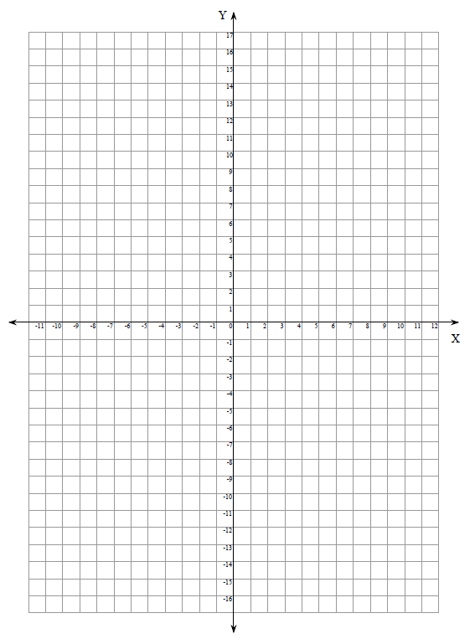
B
C
A

C

A

