Name: __________________________________ **Jan. 26, 2016**

**Slope Homework: Types & Rise/Run**

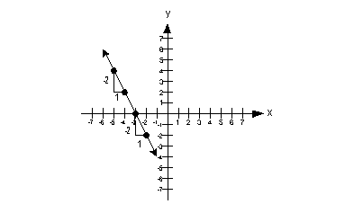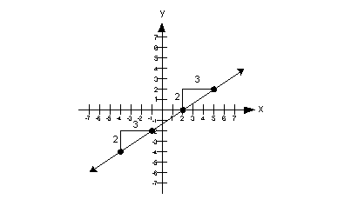**Directions: Use the two given points to find the slope of each line.**

1. **2.**

Positive

**What type of slope is it?**

**______________________________**

**What type of slope is it?**

**______________________________**

**______**

\



**3. 4.**

**What type of slope is it?**

**______________________________**

**What type of slope is it?**

**______________________________**

**SLOPE = SLOPE =**

**___________________________ ___________________________**

**5.**  **6.**

**6.**

**What type of slope is it?**

**______________________________**

**What type of slope is it?**

**______________________________**

**SLOPE = SLOPE =**

**___________________________ ___________________________**



**8.**

**7.**

**What type of slope is it?**

**______________________________**

**What type of** slope is it?

______________________________

**S**

**SLOPE = SLOPE =**

**___________________________ ___________________________**