Name _____________________________________________ Date _______________________ Period 1 2 3 6 7

Unit 5 – Linear Functions
Study Guide – Test Thursday, Feb. 11

Concepts to Know:
- Linear function formulas
  - Finding the slope using m = or a table or a graph(count rise/run)
  - Slope-intercept form f(x) = mx + b, where m is slope and b is the y-intercept
- Graphs of linear functions
  - Graphing slope-intercept lines, using a starting point,”b”, and then count rise/run for slope and plot additional point
  - Horizontal lines (y = #) and vertical lines (x = #)
- Modeling (application) problems
  - Meaning of slope: a constant rate of change or steepness of a line.
  - Use direct proportion to find unit rate
  - Turning word problems into function formulas (equations)
  - Domain and range/independent vs dependent variables)
  - Evaluating/solving (see above) and giving the meaning of the answer in the problem context
  - Solve problems by comparing slopes and making a choice

Review Problems:
- Write the function formulas for these lines:

- 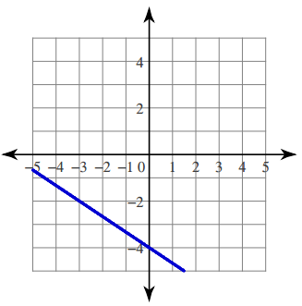 b. 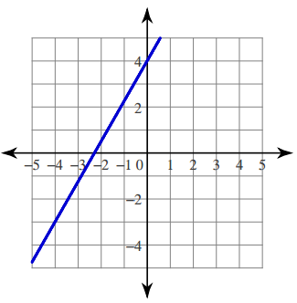 c. 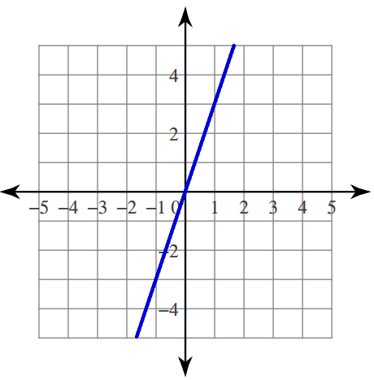

- Find the slope of the line that contains the given points:

- (-3,5), (-3,9) b. (4,7), (-2,-7) c. (-11,2), (2,-11)

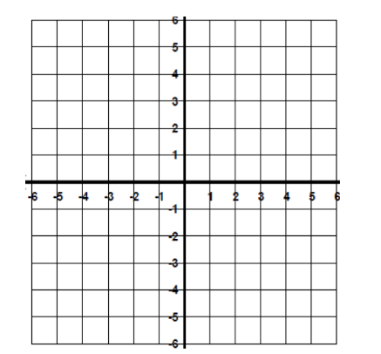
- Graph these equations:
- $x= -3$ b. $y= -\frac{1}{3}x+2$ c. $y= \frac{3}{2}x$

- Find the slope and y-intercept of the line represented by each equation:
  - $y=6x+3$ slope: y-intercept:
  - $y=7-9x$ slope: y-intercept:
  - $y= -13x$ slope: y-intercept:
  - $y=8$ slope: y-intercept:

- Use the given information to write a linear equation in slope-intercept form:
  - Slope is -2 and the y-intercept is -6
  - Slope is $\frac{3}{7}$ and the y-intercept is -1
  - m = -8 and b = 11
  - m = 0 and b = -5
  - m = -11 and the y-intercept is (0,13)

- You and your friends are going to the carnival. There is a $5.00 entrance fee and ride tickets cost $0.50 each.
  - Write the function equation to represent the situation.

  - What would be the cost for 5 rides? 10 rides?

  - Graph the function, with y representing the total cost and x representing the number of rides.

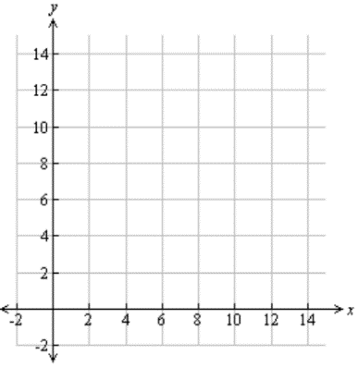

- A car is driving down from the top of a Colorado mountain. The elevation at the top of the mountain is 13,500 feet. Every minute of driving, the car’s elevation decreases by 150 feet.

$$x=the time in minutes that the car as been driving$$
$$y=the car^{'}s elevation in feet$$

- Write the function equation to represent the situation.

- Evaluate when $x=5$ and explain the meaning of the answer in terms of the car.

- Patricia is saving money to buy new shoes. The shoes she wants cost $85, and she has already saved $18. Her goal is to save enough money to buy the shoes in 6 weeks. Write an equation to represent how much money she will need to save each week to reach her goal.

- Find the unit rate for each situation:
How much for 1?
  - It costs $3 for 5 cartons of milk

  - Quentin drove 240 miles in 4 hours

  - Six apples for $4.50

- The table and the equation each represent a different linear function. What is the difference between the rates of change? (Hint: Find the rate of change for each function first.)
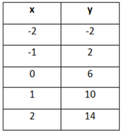
$$y= -\frac{1}{4}x+5$$

- Which graph represents a direct proportion? Explain how you know.
  - 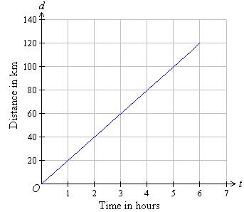 b. 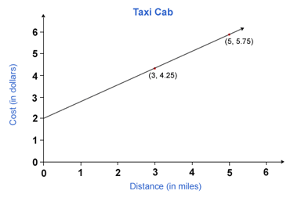

- A hot air balloon rises at a constant rate. The height of the balloon after 12 minutes is 4,140 feet. The height after 18 minutes is 6,210 feet. What is the change in elevation of the hot air balloon per minute?

- Two triangles are drawn on the coordinate plane. Write a proportion that proves that the slope of the hypotenuse of each triangle is the same.
