**Math 8** Name ________________________________________  
**Unit 6: Linear Models & Tables** Date ____________Period 1 2 3 6 7  
**Study Guide**

1. What is another name for “initial value”? ___________________How can you recognize it on a graph? ___________________ How can you recognize it on a table? ______________________________
2. When you are writing a “line of best fit” (aka “linear model”) from a scatterplot, first you choose _____________________ and find the ________________. Then you use the ________ and one point to write the ____________ equation. Rewrite your equation in ________-____________ form.
3. What is another word for “rate of change”? ____________ How do you find “rate of change” from a table? ________________________. If the rate of change is positive, the function is increasing/decreasing (circle one). If the rate of change is negative, the function is increasing/decreasing (circle one).
4. Write an algebraic equation that describes the relationship between *x* and *y*.

|  |  |
| --- | --- |
| ***x*** | ***y*** |
| 0 | 5 |
| 1 | 11 |
| 2 | 17 |
| 3 | 23 |
| 4 | 29 |

|  |  |
| --- | --- |
| ***x*** | ***y*** |
| 0 | 3 |
| 1 | 8 |
| 2 | 12 |
| 3 | 17 |
| 4 | 21 |

1. Does this table represent a linear function? Why or why not? _____________________________________
2. Draw a graph that has a slope of -4 and has an initial value of 6.

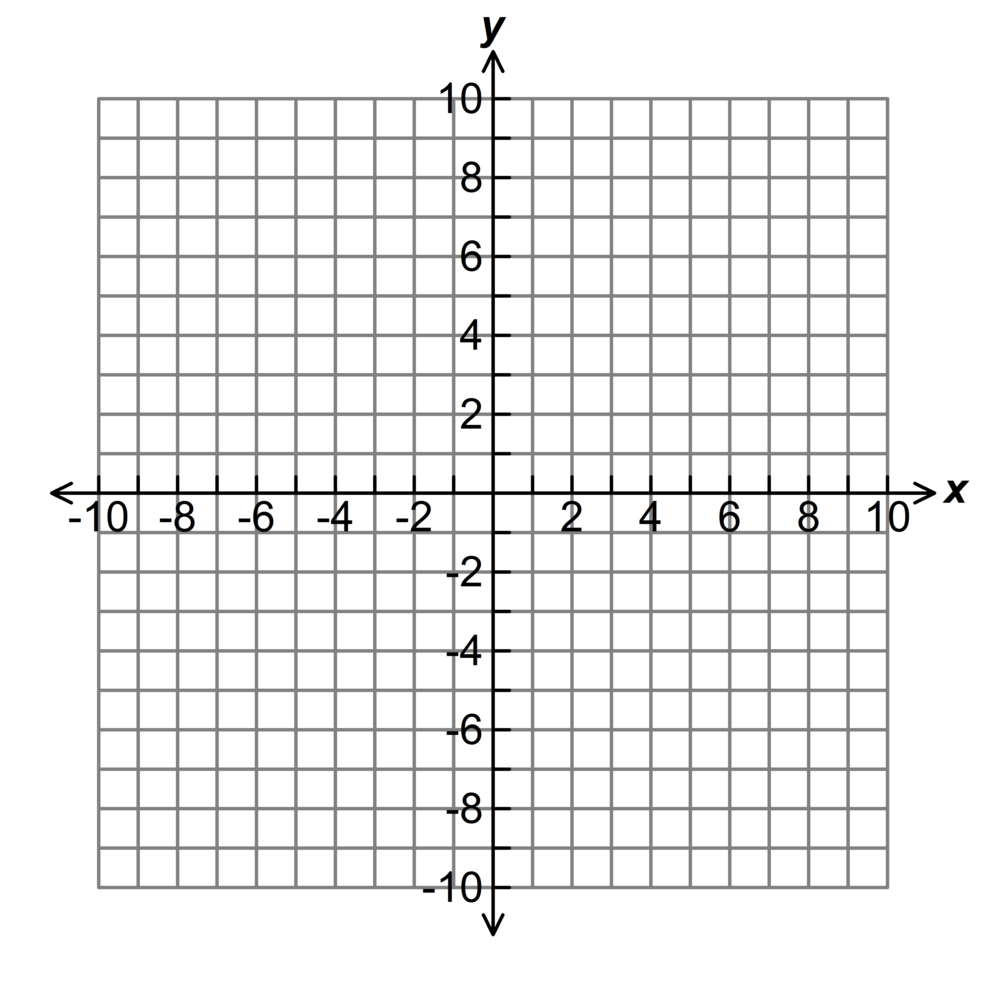

1. What is the linear model (equation of the line) that represents the graph in #6? ___________________________

8. Find the “rate of change” for each of the following and tell whether it is increasing or decreasing:

A.  _______ __________________ B.  ________ _______________________

C.  _______ ___________________ D.  ________ _______________________

9. Which equation in #8 has the least rate of change? __________ which has the greatest rate of change?_________

1. Determine the rate at which a hot air balloon rises given the information in the table:

(note: the balloon is tethered, not touching the ground, at take-off). ***Interpret what the rate means.***

|  |  |  |  |  |  |  |
| --- | --- | --- | --- | --- | --- | --- |
| **Minutes** | 8 | 12 | 20 | 25 | 28 | 30  **Rate:** ________________________________ |
| **Height (ft.)** | 99 | 147 | 243 | 303 | 339 | 363 |

1. Write the equation which represents the height of the hot air balloon as a function of minutes during flight.

**Equation:** _____________________________

1. [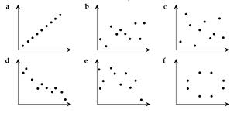](http://www.google.com/imgres?hl=en&tbo=d&biw=1024&bih=571&tbm=isch&tbnid=Lfb-9-eGU7JmNM:&imgrefurl=http://cshsyear10maths.global2.vic.edu.au/using-data/v-scatter-plots/&docid=d2pNi-JuK1Ty2M&imgurl=http://cshsyear10maths.global2.vic.edu.au/files/2008/10/int-splts.png&w=715&h=343&ei=bPMYUbO0B5Ho8QSY84CIBA&zoom=1&iact=hc&vpx=518&vpy=233&dur=2850&hovh=155&hovw=324&tx=136&ty=78&sig=113315540462232664669&page=2&tbnh=136&tbnw=272&start=16&ndsp=21&ved=1t:429,r:19,s:0,i:143)Identify the patterns for each of the scatter plots as positive or negative association, strong or weak, linear association, nonlinear association, no correlation and/or outliers-there may be more than 1 answer for each graph. Write the description on each graph. (notice there are 9 graphs)

[](http://www.google.com/imgres?hl=en&tbo=d&biw=1024&bih=571&tbm=isch&tbnid=Lfb-9-eGU7JmNM:&imgrefurl=http://cshsyear10maths.global2.vic.edu.au/using-data/v-scatter-plots/&docid=d2pNi-JuK1Ty2M&imgurl=http://cshsyear10maths.global2.vic.edu.au/files/2008/10/int-splts.png&w=715&h=343&ei=bPMYUbO0B5Ho8QSY84CIBA&zoom=1&iact=hc&vpx=518&vpy=233&dur=2850&hovh=155&hovw=324&tx=136&ty=78&sig=113315540462232664669&page=2&tbnh=136&tbnw=272&start=16&ndsp=21&ved=1t:429,r:19,s:0,i:143)

[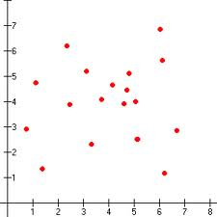](http://www.google.com/imgres?hl=en&tbo=d&biw=1024&bih=571&tbm=isch&tbnid=jnIQ_0G_-cwn_M:&imgrefurl=http://hotmath.com/help/gt/genericalg1/section_11_3.html&docid=_xbVXdvl6KAYDM&imgurl=http://hotmath.com/images/gt/lessons/genericalg1/no_correlation.gif&w=300&h=300&ei=bPMYUbO0B5Ho8QSY84CIBA&zoom=1&iact=hc&vpx=752&vpy=227&dur=93&hovh=225&hovw=225&tx=160&ty=143&sig=113315540462232664669&page=3&tbnh=144&tbnw=144&start=37&ndsp=21&ved=1t:429,r:57,s:0,i:264)[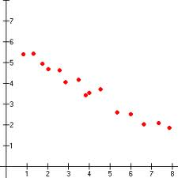](http://www.google.com/imgres?hl=en&tbo=d&biw=1024&bih=571&tbm=isch&tbnid=aGrh5YxeV8NTEM:&imgrefurl=http://hotmath.com/help/gt/genericalg1/section_11_3.html&docid=_xbVXdvl6KAYDM&imgurl=http://hotmath.com/images/gt/lessons/genericalg1/negative_correlation.gif&w=300&h=300&ei=bPMYUbO0B5Ho8QSY84CIBA&zoom=1&iact=rc&dur=358&sig=113315540462232664669&page=4&tbnh=143&tbnw=143&start=58&ndsp=22&ved=1t:429,r:69,s:0,i:300&tx=33&ty=61)[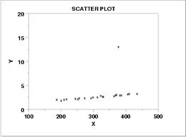](http://www.google.com/imgres?hl=en&tbo=d&biw=1024&bih=571&tbm=isch&tbnid=g2wTflAm-bI4hM:&imgrefurl=http://www.itl.nist.gov/div898/handbook/eda/section3/scattera.htm&docid=SocHGG3bmLK59M&imgurl=http://www.itl.nist.gov/div898/handbook/eda/section3/gif/scatploa.gif&w=380&h=280&ei=bPMYUbO0B5Ho8QSY84CIBA&zoom=1&iact=hc&vpx=538&vpy=214&dur=78&hovh=193&hovw=262&tx=113&ty=85&sig=113315540462232664669&page=4&tbnh=141&tbnw=196&start=58&ndsp=22&ved=1t:429,r:61,s:0,i:276)

g. h. i.

1. Mellow Mushroom is selling plain cheese pizzas for $12 and each additional topping is $0.40.

**T toppings cost P**

1. Create a table showing the price *P* you would pay for a pizza

with *t* toppings.

Include values for 0 to 10 toppings in increments of 2.

1. What is the rate of change?_________
2. What is the initial value?________

What does initial value represent?_______________

1. Write an equation relating the cost of a pizza “*P*” and

number of toppings “*t*”

______________________________

1. Jaxon spent a week camping and hiking. The data of each hike is recorded in the table. Plot the graph.

Be sure to label your axes.

|  |  |  |  |  |  |  |  |
| --- | --- | --- | --- | --- | --- | --- | --- |
| Time | 1 | 1.5 | 2 | 4.5 | 5 | 6 | 7 |
| Distance | 3 | 5 | 6 | 8 | 9 | 9.5 | 10 |

[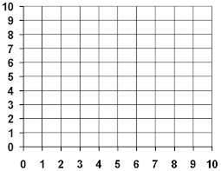](http://www.google.com/imgres?hl=en&tbo=d&biw=1024&bih=571&tbm=isch&tbnid=xB-eUg0ZB9FRhM:&imgrefurl=http://www.mathsideas.com/pages/show_resource.php?resource_id=64&docid=l-P4QbqbCKvckM&imgurl=http://www.mathsideas.com/resources/1347130506-1%20quadrant%20grid.bmp&w=635&h=491&ei=ogQZUcqYBoTi8gSmrQE&zoom=1&iact=rc&dur=435&sig=113315540462232664669&page=1&tbnh=137&tbnw=177&start=0&ndsp=20&ved=1t:429,r:12,s:0,i:184&tx=94&ty=59)

1. Draw a line of best fit (linear model).
2. What is the initial value? _______________
3. What is the rate of change?_____________
4. Write the equation for the line of best fit_______________________
5. What is the correlation of the 2 values?_______________
6. [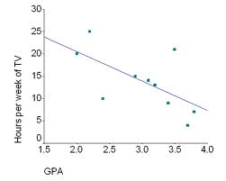](http://www.google.com/imgres?hl=en&tbo=d&biw=1024&bih=571&tbm=isch&tbnid=gmiHJrYXWqHo-M:&imgrefurl=http://www.nvcc.edu/home/elanthier/methods/correlation.htm&docid=DWLg_zlBiX1coM&imgurl=http://www.nvcc.edu/home/elanthier/methods/Image3.gif&w=566&h=453&ei=LgcZUavIEpL69gSRuoDADw&zoom=1&iact=rc&sig=113315540462232664669&page=1&tbnh=136&tbnw=175&start=0&ndsp=16&ved=1t:429,r:0,s:0,i:82&tx=91&ty=45) How far do you predict Jaxon will hike after 10 hours? _________
7. Analyze the scatter plot to the right:

Interpret the correlation between the variables.

_______________________________________________

________________________________________________

What equation could you use to determine your score based on the number of hours studied? (in other words, what is the approximate equation of the line of best fit…aka the linear model)

________________________

*remember the rate of change is the change in y OVER the change in x; y-y OVER x-x.

**Choose the correct answer.**

1. Sarah is almost to her friend’s house for a sleepover (Sarah’s house is at 0 distance). She gets homesick and starts walking home. Then she realizes how much fun she would have at the sleepover and runs to her friend’s house. Which graph represents her travels?



1. This table shows a linear relationship between 2 quantities. Find the equation that represents this relation: _______________________

X 0 2 4 6 8 10

Y 4 10 16 24 30 36

1. [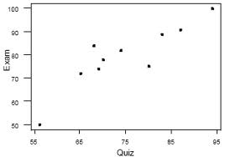](http://www.google.com/imgres?start=138&hl=en&tbo=d&biw=1024&bih=571&tbm=isch&tbnid=FJi8SZLSYeFa4M:&imgrefurl=http://onlinecourses.science.psu.edu/stat100/book/export/html/21&docid=3c_fVd-CXxaDDM&imgurl=https://onlinecourses.science.psu.edu/stat100/sites/onlinecourses.science.psu.edu.stat100/files/lesson08/plot_07.gif&w=350&h=245&ei=NQ0ZUd_1H5Ci8ASfoIHADw&zoom=1&iact=hc&vpx=709&vpy=247&dur=1465&hovh=188&hovw=268&tx=132&ty=79&sig=113315540462232664669&page=8&tbnh=142&tbnw=202&ndsp=20&ved=1t:429,r:57,s:100,i:175)Write an equation for the line of best fit comparing quiz grades with exam grades___________________
2. Complete the two way table below with the given information:

At Palmer Middle school, there are 1,100 students. Of those students, 550 are female. Our band program has 376 male participants, while 245 female students do not participate in band. There are 681 students in the band program.

|  |  |  |  |
| --- | --- | --- | --- |
|  | Male | Female | Total |
| Band |  |  |  |
| No Band |  |  |  |
| Total |  |  |  |